Record No: 0631
BELLINGHAM ARTHUR SOMERVILLE (BAS)
of Clermont, Rathnew,. Co Wicklow

4th son of Tenison Alan Somerville (0591) by his wife Cecilia Eliza(0592), daughter of
Daniel O’Connor (0592) of Shoreham, Sussex by his wife Elizabeth daughter of John
Ritchie..

Birth: 17 Nov 1853 at Ruthville, Philipsburgh Ave, Dublin
Bapt: 16 Jun 1854, St Thomas’ Church, Dublin
Marriage: 27 Aug 1879, St Mary’s Church,Witney, Oxon, Margaret Hall
(0632) younger daughter of William Clinch(0633) of The Elms, Witney,
Oxfordshire by his wife, Rachel Hall, daughter of John Wright of
Curbridge, Oxfordshire.
Death: 16 Jan 1916 at Clermont, Rathnew, Co Wicklow.
Burial: 20 Jan 1916, at Wicklow Churchyard

: District Inspector, Royal Irish Constabulary
SR3023 19 May 1893, Admitted to the Freedom of City of Dublin by birth

Sometime Director - Clinch & Co Ltd

Source: Somerville Index

Notes:

Father of:
William Arthur Tenison Bellingham Somerville (Bunt)(0660)
James Aubrey Henry Bellingham Somerville (Jim)(0663)
Alan Everard Whichnour Bellingham Somerville (Alan)(0666)
Gualter Hugh Rodger Bellingham Somerville (Pat)(0667)
Reginald Malcolm John Bellingham Somerville (Regi)(0670)
Cecilia Eliza Margaret Bellingham Somerville (Cecil)(0675)
Dorothy Alrewas Hester Bellingham Somerville(Dorothy)(0677)
Vere Frances de Merlie Bellingham Somerville(Vere)(0678)
Edeline Botelier Marjorie Bellingham Somerville(Tetty)(0680)

BAS’ life is best considered in three parts; the early years up to his marriage in 1879, the middle years up to his retirement in 1891 and the ‘Clermont’ years from 1891 until his early death in 1916.

The Early Years

Little is recorded about BAS’ childhood except that, unlike his children, he was sent to school in Dublin where he was born in 1853; it has been suggested that he was assertive or precocious and was known as ‘Fighting Attie’. He was the fourth of five brothers born to Tenison Alan Somerville (0591), who, following his return from Trinidad in 1846, had secured a position as a public servant in the secretariat of the RIC in Dublin Castle. His eldest brother, William Denniston Somerville, who was born in Trinidad in 1842, was dumb following a disastrous operation in early childhood and lived quietly with his parents and subsequently with BAS and his wife; his second brother, Tenison Alan Somerville, also born in Trinidad in 1845, died at the age of ten in 1855 after the family had come back to Ireland; his third brother, Henry Bellingham Somerville born in Dublin in 1848, was a District Inspector in the RIC; his youngest brother, also called Tenison Alan Somerville (Sonnie), born four years after his namesake’s death in 1859, seemed to have suffered throughout his life from some unrecorded psychological impediment and, although able to live a relatively normal life, was at all times in the care of his parents, his brothers Henry or BAS and, after his parents’ death, his sister, Erina (Cis/Amy), and her husband The Rev. Thomas Rolfe, in Yorkshire. Amy was born in Dublin in 1851.

BAS started a personal diary on 9 July 1869, when he was 15 years old, which, however, was written up subsequently from letters and memoranda. This shows enjoyable teenage years; from July to December 1869, he was with Henry who was stationed at Claremorris in the west of Ireland, walking and mountaineering, fishing and shooting, hunting, with Henry’s men, for ‘poteen’, ‘stills’ and ‘worms’ and making large siezures, visiting archeological sites, and staying with various friends. This was the pattern for two or three years. At home, initially, 48, Gloucester Street in the City and subsequently, Prospect House, Ranelagh, there was much entertainment and dancing. BAS was already showing an interest in history; the entry for 21 September 1870 reads “When in Trinity College this day, I saw the skeleton of John Temple, Provost of the College in 1609. He was buried in 1689 but where was unknown till this day when some workmen digging up the ground under the central tower in the College (the Campanile) came upon the coffin. I believe that the late Palmerston some years ago made a very strong effort to find out where John Temple, his ancestor, was buried but could not succeed.” BAS had already started his family research; the entry for 16 December 1870 reads as follows: “Father’s birthday. I finished this day the first genealogical tree I ever made of our family and gave it to P. It is six feet five inches long by eighteen inches broad and has taken me from 28 April to make, seven months and two days”. 1871 continued in the same vein;1 June – a dance at Prospect, 17 June – Civil Service Sports at Exhibition Gardens, I ran 3rd in 100 yards race, Sonnie got 2nd in the boys’ race. Had dance at Prospect, Josie Armstrong and the two Miss Williamsons staying here, 20 October – had a letter from Sir Alan Bellingham enclosing an introduction to the Library of the Royal Dublin Society, 27 November - I went in the evening to the opening of the Gaiety Theatre, Mrs Scott Siddons read the address; the play was ‘She Stoops to Conquer’ followed by ‘La Belle Sauvage’

1872 sees BAS’ first contact with the RIC. On 20 April he receives a nomination for cadetship; there were two vacancies, eight candidates, so he began to work hard with the Tutor, Mr Crawley. On 7 May he was medically examined and had an oral with the Inspector General, Col Sir John Stewart-Wood. 28 to 30 May, he sat the exams.
The entry for 16 June “I got a letter from the Civil Service Commissioners in London saying that I had got first place at the examination. All were very glad. Poor Mother cried over it” 11 July 1872 – “I joined the RI Constabulary Depot, Phoenix Park this day”

On 19 July 1872 BAS was issued his Journal at the Phoenix Park Depot and started life as a Cadet; the journal remained with him throughout his career and was entered up daily until sickness forced him to leave office on 3 August 1890. After ceaseless parading, drilling and orderly duties at the Depot, he was posted to take charge of the Charleville district in north west Cork on 1 February 1873. District duties included parading and drilling, ball firing, inspecting sub Barracks at sub districts all over north Cork and east Limerick –Milford, Buttevant, Liscarrol, Churchtown, Kilmallock and Freemount – attending Assizes and Petty Sessions, investigating outrages, arresting and prosecuting felons, dealing with insubordination of the men, paying staff and pensioners, attending, with mobile patrols, disturbances within and without the District etc. Times were disturbed and getting worse with the Fenian troubles being followed by Land League intimidation and seizures and wounding of stock, non payment of rents and subsequent evictions. But BAS also had a social life; he was constantly visiting , either on short leave or ‘private business’ places such as Limerick, Cork, Rathkeale, Mallow, Kilfinnane, Newcastle, Youghal and Dublin. When he left the District on transfer to Newtownhamilton in Co Armagh on 1 March 1876, owing to the amalgamation of Charleville with Mallow and Kanturk, his private diary records – “ I have served three years at Charleville and during that time enjoyed myself but ran heavily into debt. I found all the people very kind to me and attended all the gay doings in Cork and Limerick and on the borders of Tipperary and Waterford during that time. The following families were very hospitable and kind to me and many a pleasant day I spent at their places. Sanders of Sanders Park, Harrisons of Castle Harrison ( his eldest son Bunt was to marry General Harrison’s eldest daughter Kitty 50 years later), Hutchins of Fortlands, Barrys of Kilbolane Castle, Drews of Drewscourt, Sheltons of Rossmore, Weldons of Cooline, Bruces of Miltown Castle, Sullivans of Curramore, Weldons of Highfort, Barrys of Ballyvonaise, Moore- Smyths of Ballynatray, Creaghs of Creagh Castle, Franks of Carrig Park, Wilkinsons of St Oswalds, Finches of Maryville, The O’Gradys of Athlacca. The 1st Battalion of 20th Regt under Col Davies and afterwards a Battalion of 25th Regt under Col Ruddell were at Buttevant nine miles from Charleville and I spent a great portion of my time with them”. While at Charleville and throughout his career, BAS kept buying and selling horses; whether for personal or professional use, is not clear. Clearly, however, he was having an enjoyable time, and, no doubt, living above his means.

While the duties at NewtownHamilton were, in theory, much the same, they were more intense; there seemed to be more numerous and more serious disturbances. The District included Keady, Cullyhanna, Crossmaglen, Silverbridge and Carnagh. But there was still time to make visits on private business to Portadown, Armagh, Newry and Castleblayney. BAS, however, seemed to have a ‘flying’ squad of men and he was detailed to attend Orange disturbances and open riots outside his district, particularly in Belfast .

On 1 March 1878, he was ordered to proceed to the Phoenix Park Depot and to report to Dublin Castle the following day. The reason is not clear, but there follows a period of five and a half months’ parading and drilling, as if he had been in some trouble; indeed, on 30 April 1878, he was suspended from duty and pay until the following 1 July when he was reinstated in rank and pay. On 13 August, he resumed command of Newtownhamilton. Even during his period at the Depot, he was put in command of a ‘flying’ squad of 20 men from the Co Carlow force to attend the Orange anniversary on 12 July at Gilford, Co Down.

During his time at NewtownHamilton, BAS started suffering from recurring bouts of neuralgia and headaches and put himself on sick leave; he also sprained his ankle early on in his career, and he had continuing trouble with it, so much so that he was dragged down by it constantly until he was forced to retire. The bright part of his stay in Co Armagh, were his visits to Witney and his engagement to Margaret Hall Clinch in January/February 1878.

The Middle Years

On 1 April 1879, BAS was transferred at his own request to Newtownards, Co Down. This was a large and important urban centre, with substantial, populous sub districts and barracks at Comber, Kircubbin, Holywood, Bangor, Killinchy, NewtownBreda, Donaghadee, Greyabbey and Portaferry. With his greater responsibilities and marriage to Margaret Hall Clinch on 27 August 1879, social activities seem to figure less prominently; rather, the duties of the larger district seem more widespread and onerous. The disturbances caused by the activities of the Land League, now the National League, and the potential for disturbance caused by elections and the ceremonies of the Orange Order, see BAS in action with a ‘flying’ squad in such distant places as Coleraine, Trim, Dungannon and Belfast. He spends January and February 1881 at Hollymount in Co Mayo where a new District is formed and where on 22 January, he is protecting John Lynskey, bailiff to Capt Boycott near Balla, with 50 men and a company of the 76th Regiment in expectation of trouble from the Land League at evictions. Back in Newtownards, he is protecting Lord Annesley for two months, until his lordship finally departs Ireland; and constantly patrolling Clandeboye. The entry for 7 May 1882 reads:” At office. Received telegram stating that Lord Frederick Cavendish (the Chief Secretary) and J H Burke (the Under Secretary) had been murdered in the Phoenix Park at 7.15 pm last night. Telegraphed to all the outstations; had suspects looked up and the trains and cars watched. On patrol from 6.00pm to 8.00 pm and from 10.00pm till 1.00am.”

By 1883, he is seeking a transfer; on 1 May he is transferred at his own request to Queenstown, Co Cork. This again is a substantial and populous district, with the added responsibility of supervising visiting trans Atlantic ships, which feature frequently in the journal. Criminals wanted in America are seized and those suspected of fomenting trouble in Ireland are investigated. The sub districts include Glanmire, Passage, Spike Island (a holding base for prisoners whch involves escorted transfers to Mountjoy in Dublin), Haulbowline, Monkstown, Crosshaven and others. BAS is still involved with a ‘flying’ squad; in July 1886, he goes the whole way up to Downpatrick in Co Down on special duty. He still suffers from a sore foot.

The journal for 8 March 1887 and the following days reads as follows:
“At office. Inspected Crosshaven at 10.15 am, Passage West from 11.30 am till 12.00. Proceeded by 5.00 pm train to Youghal (on the border of Co Cork and Co Waterford) on ? duty. On march from Railway Station to the Barracks, we were ferociously attacked and I charged the mob three times when they were dispersed. One man Patrick Hanlon died from a sword stab inflicted in the charge”
9 March to 22 March 1887:
“On duty in Youghal. A verdict of culpable murder preferred by Coroner’s jury against Const. Ward and myself.”
23 March 1887:
“I was arrested by D I Kerin of Youghal and lodged in the County jail with Const Ward.”
24 March to 30 March 1887:
“In County jail. By Order of the Queens Bench, I was released this day on bail myself in £500. Const Ward also released on his own bail £50.”
1 April 1887:
“Returned to Queenstown at 1.30 am but did not resume duty.”
(Journal inspected 14 June 1887)
28 July 1887:
“A Nolle Prosequi having been entered by the Attorney General at Assizes in case of murder against Const Ward and myself, I resumed duty this day. Attended at Divisional Magistrate’s Office on duty.”
29 July 1887:
“At office. Took charge of District.”
For the next few months, BAS carried on his normal duties, but there were frequent meetings with superiors on confidential business, other District Inspectors, County Inspectors and Divisional Magistrates. One can imagine that it would have been difficult for BAS to continue as DI in Queenstown, so near to Youghal.

On 1 December 1887, BAS is transferred at his own request to Wicklow. The district is far flung; it embraces Wicklow, Redcross, Rathdrum, Avoca, Arklow, Rathnew and Ashford and elsewhere. The duties are much the same as in previous districts, although he is frequently called to protect Protestants at open air religious meetings in Arklow, but the journal shows that after the initial two years, his heart doesn’t seem to be in it. He suffers increasingly from his sore foot, lameness, sore throat and swollen face and unspecified sickness; and takes numerous single days leave. For instance, in January 1889, he is out sick for 6 successive days, then in the office for 1 day, then on 1 day’s leave, followed by 6 successive days sickness, 1 days leave and 2 days absence with a lame foot. Similar patterns of sickness emerge for the next two months; in March he describes himself on three occasions as being ‘very ill’. In April 1889, he is sick all month and again between 1 and 16 May. He then goes on leave between 17 May and 2 June, resuming duty on 3 June 1889. By the summer of 1890, he is sick again and the journal finally ends on 2 August 1890 when he stays at home sick. In effect, BAS ceases duties in 1890 although the belief is that he formally retired in the following year.

There seems to have been something of a shadow over BAS’ career; he was obviously a popular officer; perhaps unambitious; with several unexplained hiccups in the initial years. He held good appointments in NewtownHamilton and Newtownards, but why was there no promotion to County Inspector? Was his candidature for promotion the reason for the five month session at the Depot in 1878? He was then still only 25 and, for some unknown reason, he blotted his copy book temporarily while at the Depot. However, after the trouble at Youghal, it would have been politically difficult to secure promotion. One can imagine the howls of protest from the nationalist community and Roman Catholic Church. He seems thereafter to have been dispirited, as one would suspect, and plagued by ill health. It is, perhaps, not surprising that he threw in the towel , even though he was still under 40 years of age.

The Clermont Years

Regi said that after his retirement BAS wanted to buy Myrtle Grove in Youghal; it is a charming 15th/16th century town house that had belonged to, or, at any rate, occupied by Sir Walter Raleigh and one can still see the attractions. He was advised against it, for obvious reasons. There followed a number of moves; the family rented Friars Hill, in Wicklow Town between 1890 and 1892; it seems they may then have moved to 82, Harcourt Street in Dublin for two years. By 1894, Clermont, at Rathnew, was on the market. It would, undoubtedly, have been known to BAS when stationed in Wicklow. In fact, the Chomley family, who held the Fee Farm Grant of the property since the 1840s had fallen on hard times and the Landed Estate Court had been seeking a buyer since 1879. An auction was directed in 1894 and, although BAS bid for it, the successful bidder was Col C G Tottenham of Ballycurry, Ashford. It is said that he didn’t wish Clermont to fall into undesirable hands. Immediately after the auction, he offered the place to BAS, whom he had known when the latter was in Wicklow, for the price at which he had bought it - £1,800. The property was in appalling condition, so BAS and the family had to continue renting while repairs and alterations were undertaken. They therefore rented Ballyhenry near Ashford from Dr Truell, and, thereafter, Seaview House in Wicklow Town which they had occupied when BAS was first appointed to Wicklow in 1887.

After the purchase, Clermont was fully renovated and plumbed. Two new wings were added. The wing on the northern end was two storey and contained a sewing room , a dark room, a small study and kitchen quarters on the ground floor, three bedrooms, dressing room, bathroom and servants rooms upstairs. The south wing, which was of larger scale and proportions,but single storey, so as not to unbalance the appearance of the house, contained a large drawing room, a billiard room, long panelled passage and hall and cloakroom with a door leading to the grounds on the south of the house. The ceiling in the drawing room was elaborately decorated and that in the billiard room had circular windows in the roof and a frieze decorated with the Somerville crest and arms.

Cecil who was 14 years old when BAS bought the property describes the place at that time as follows:
“At one time all the land round and about belonged to the Yarners and the family ultimately ended with three sisters, either daughters or grand daughters of Sir Abraham Yarner. The property was divided into three portions, now (1944 when this was written) represented by Clonmannon, Clermont and Rossanagh, and each girl received one. The girl to whose lot Clonmannon fell married a Truell (when she was a widow, her name being Catherine Stone, many years older than Holt Truell) and there have been Truells at Clonmannon ever since. The other two shares, either by marriage or purchase, fell into other hands and in time were divided up. There was an old house at Clermont which stood somewhere about where the present stables are, but that house was burnt down, and the present house has its date over the front door – 1730. (In fact, the old house stood in the south west corner of the yard)
There was a Rev. Francis Chomley, M.A.,who was Rector of Wicklow. He had a son Francis and two daughters, Jane and Lucy. (In fact, he had three daughters). The Chomleys kept up great state at Clermont and the gardens were particularly nice with lavender hedges etc. Francis Chomley was a tea merchant in China, and, after his father’s death, he used to send money to his sisters for the upkeep of the place. After some years, he returned home and was horrified to find that they had neglected everything, and that they had let the house, garden and all, fall into a state of disrepair. He had had bad sunstroke abroad, and the disappointment when he got home quite turned his brain and he set to destroy everything. He broke down a forge, laundry and dairy which were in the yard, and a forge near the village, tore up hedges and cut down many fine trees in front of the house and let in the villagers to collect the wood. He laughed at them fighting over it. According to Matty Doyle (1944) who lived in a pretty cottage at the corner of the Rathnew/Newrath road with Tighes Avenue, there was an entrance to Clermont at the end of the moat field, and the avenue came up through the moat field, sandhill field and Rathnew field, and through a gateway with large gateposts into the wood opposite Clarke’s farm.(This became the ‘Jubilee Avenue’ to mark Queen Victoria’s Jubilee, started by BAS, but not totally finished).
The field on the left hand side of the path going down to the gardens was known as Keogh’s field because a man named Keogh live in a cottage in the N.W. corner of the field which looked onto the lane running along the boundary of Clermont , known as the Bullock Walk. Along the side of the garden, the paths went around a moat which went down the west and south of the garden and was fed by a small stream from the Rathnew river. Inside the garden were many small flower beds enclosed by box hedges, and beyond that a high laurel hedge with three arches and a granite pillar for a sundial in the centre.
After we settled in, my father made many improvements. (Perhaps, all or some were made before they moved in as they continued to rent until 1895 and there was evidently snow on the ground when they moved in) He added two wings to the house, made a large lawn in front, then a terrace at the back, widened the path to the garden, and planted trees and shrubs on each side. He enlarged the moat on the west side into a large pond. Sir Thomas Drew, the architect for the new wings, and Messrs Pemberton, the builders, while doing repairs to the coachman’s house, discovered a cornice. This, it was thought, must have been part of the old house which is said to have stood in the present stableyard and is said to have been burnt down. Sir Thomas very much admired the old belfry in the yard wall near the house. He thought it was Flemish work. In later years, we were told it was one of the last examples of Flemish work in Ireland.(This was taken down by the nuns who ultimately bought the property)
By the large beech trees outside the garden gate, there was a lavender bush when we first came to Clermont. Old Kinsella, who lived at the lodge with his wife, Judy, said this was all that was left of the old lavender hedge of which there used to be so much at Clermont. There is still (1944) an old myrtle tree by the small gate going into the yard from the house.
Clermont was sold by Jane and Lucy Chomley in 1894 by auction. My father bid for it, but it was bought by Col Tottenham. Afterwards, he did not want it and let my father have it for the price he had paid. Francis Chomley had died, and his two sisters were very old ladies who had lived in great poverty. They were not on speaking terms and one old lady lived up in the drawing room and the room off it, and the other in the dining room and the study, with an old woman who attended on them living in the basement.
Clermont was a large square house, in bad state of repair. When we went there, it was reroofed and entirely done up, both within and without, and the coachman’s house rebuilt. There was an open area all around the house. In the N.W. corner of the area, there was a broad flight of five stone steps leading up to a path which ran through a shrubbery to the pond. There was also a large shrubbery on the south side which contained a dry closet with seven seats! (This was still in situ when Clermont was sold; a fine example of early 18th century architecture)”.

There seems little doubt that the Youghal incident affected not only BAS himself and his career, but the whole family; in particular, the sons. Bunt was then 5 years old, Jim 3, and Alan 2, while Pat and Regi were not yet born. By the time the family moved to Wicklow a year or two later, one would have expected BAS to have started thinking about schools. Regi did say that Bunt and Jim had some schooling in Dublin – perhaps between 1892 and 1894 when they were at Harcourt Street. The others had none. There was a succession of governesses and tutors; Miss Shillaker, Miss Tedder (aunt of the head of the RAF ?), Miss Atwood and others; Mr Burks and others. The story is that he thought schools were cruel; one can imagine the difficulties the young boys did/would have faced with their father having been deemed responsible for the Youghal incident. Irish memories are notoriously long. Toby Truell alledged that he thought schools were ‘smutty’ places ! While the sons carried their individual difficulties into adulthood in their different ways, the girls were not really affected as governesses and the lady like arts they taught were the norm.

BAS was a skilled carpenter; and skilled generally with his hands. He was also one of the really fine early photographers, with his own dark room, and left a fine photographic legacy of about 500 plates, quarter, half and full size; these survive as an important ‘Country House’ collection – save for those taken out by Cecil and her family and not returned !

BAS was extremely ‘low church’ and had a highly developed sense of right and wrong. This may have contributed to the decision to educate the children at home. Nonetheless, he is reputed to have sacked a governess for having a cross on her prayer book. He hated the way in which women chatted after church services, considering gossip as highly dangerous. Regi said he ceased to attend church towards the end of his life for that reason. The family grave at Wicklow, in which he is buried, has no cross and doesn’t bear his name.

He encouraged his children in a wide variety of sports; hockey was the most important game, with teams being formed between Clermont and the neighbouring houses, Bluebottles and Scarlet Runners, but tennis and, even golf, were also encouraged. BAS, with others, including Morgan Crofton of Inchinappa, founded the Wicklow Golf Club on the Blainroe road; photographs of the family are to be seen in the Club house. Field sports were equally encouraged; fishing on the Vartry lakes and at Doyles on Lough Dan, shooting at Clermont, on the Lakes and at Clonmannon, ferrets were kept for the sport, and the family went otter hunting at Avoca and Woodenbridge, by train !

BAS was, of course, renowned in the family as the first member to take an interest in genealogy, not only in the Somerville family, but many others as well, both connected and not. The Somerville Records, consisting of carefully annotated indexed books, inter family letters, diaries, bibles, pedigrees, declarations and memoranda survive. The importance of them cannot be overestimated; all of them being researched and written before the disastrous fire in the Public Record Office during the Civil War where so many parish registers were destroyed. Many of these Records formed the base from which Cecil built up the genealogical papers comprised in the Rooke Papers now in the National Library. BAS’ interest started at an early age and continued throughout his life; reference has been made to his first pedigree; his last is a beautifully illustrated masterpiece, tracing the family back from the early 20th century to the 11th century, albeit, there is one acknowledged error discovered with further research and one hundred years have passed since it was made ! It fits into a fine oak box and winds down like a blind; it was formerly fixed above the double doors between the study and billiard room at Clermont.

Apart from BAS’ genealogical, photographic and aesthetic legacies at Clermont, he must be credited, together with his wife Dick, with lifting the family from the pedestrian life of the early and mid 19th century. The junior branch of the family had gradually descended to a lower social status during the first 70 years of the 19th century. While the senior branch had married heiresses in several generations which helped them enlarge and maintain their properties, and secure their social life and careers, the junior branch had not. BAS made use of such contacts as he had and with the fortune finally brought in by his wife at the end of the century, secured the family for a further generation.

Sadly, BAS continued to suffer ill health, even while building up the property at Clermont. He developed some disease that interfered with his balance (Reynier’s disease ? ); he retired from any form of social life; Regi said he was terrified people would think he had been drinking, which would offend his sense of morality. He died of flu in January 1916.

WBRBS from conversation with Regi and from the Somerville Records.

Further Research by David Gilmour:

Bellingham Arthur Somerville followed his father into the Royal Irish Constabulary in 1872 at the age of 18. He married Margaret Hall Clinch of a prominent banking and brewing family from Witney, Oxfordshire on 27 Aug 1879. The 1891 census finds him living at The Elms, Witney. He is just 36 years old and gives his profession as a District Inspector, Royal Irish Constabulary (Retired).

Investigations into his RIC record (see below) reveal that he wasn’t the best of police officers and he left the service in 1891. He was, however, admitted to the Freedom of the City of Dublin in May 1893.

The family moved to Clermont in 1895 which he extended by building the assymetrical wings. Undoubtedly, the property would have looked much better had they matched.

He was a director of Clinch and Co brewery. We know he was very interested in family history and between 1874 and
1915 gathered and archived information relating to the Somervilles from parish records, certificates, genaeological
magazines, the Dublin Record Office, British Museum, churches, letters and libraries. This later formed the basis of the
Somerville Index produced by Cecilia Rooke (nee Somerville), his eldest daughter.
Additional Research
In 1874 Bellingham Arthur Somerville had been reprimanded for failing to pay his men on time and in 1878 we find him ‘under supervision’ for ‘pecuniary embarrassments’. Sometime early in 1887 he was sent to Youghal, Cork where, following a misconceived attempt to arrest a local Catholic priest, a number of protestors gathered in an incident on Tuesday 8th March which then began to turn ugly. It seems that during the subsequent riot Somerville ordered his men to fix bayonets and charge at the stone-throwing mob. A fisherman called Patrick Hanlon was stabbed in the back and killed. The Police Constable responsible, a man named Ward, and District Inspector Somerville were held in custody while the matter was investigated.

At the coroner’s enquiry it emerged that a telegram had been sent to Youghal police with instructions to “Deal very summarily if any organized resistance to lawful authority. If necessary do not hesitate to shoot them.” Nevertheless, on 23 March 1887, a majority of 13 jurors out of a total of 18 signed a verdict which declared: ‘Constable Ward is guilty of murder. We also find Inspector Somerville guilty of willful murder by having aided, abetted and encouraged him to commit the act..’

The Attorney General for Ireland faced questions in the House of Commons immediately and the repercussions resounded for some months. PC Ward and DI Somerville were released on bail on 30 March having posted surety of £50 and £500 respectively. This is the equivalent of £4,300 and £43,000 in 2010 prices. Both men were suspended from the Irish Constabulary.

Eventually, in Sept 1887, it was decided not to prosecute – even today it is rare to see a police officer put on trial - and both Ward and Somerville returned to duty. Although Somerville had been declared guilty of willful murder by a jury he was never able to clear his name.

By November 1887 Somerville, “of Youghal notoriety” as The Times put it, had been removed to Wicklow. He continued to work for another 4 years as a 1st Class Sub-Inspector before taking retirement with an annual pension of £111 (approx £10,000 in today’s prices).

Written and researched by David Gilmour
Sources: Royal Irish Constabulary records and The Times archives.

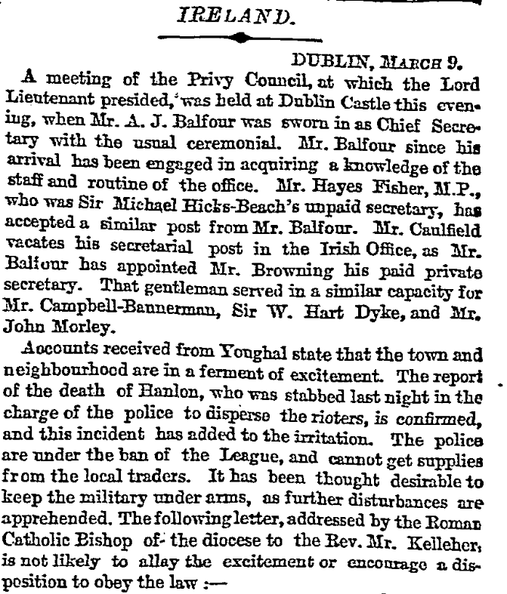
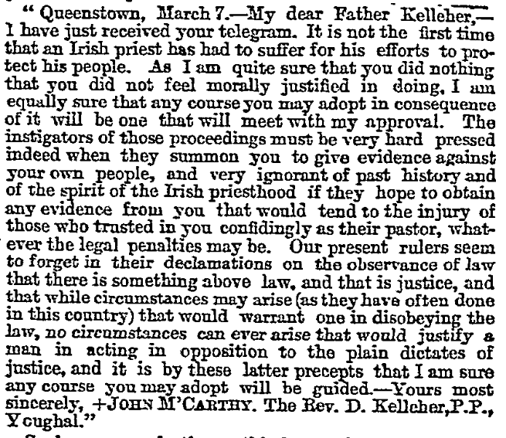
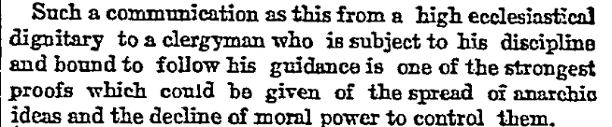
The Times, 10 Mar 1887

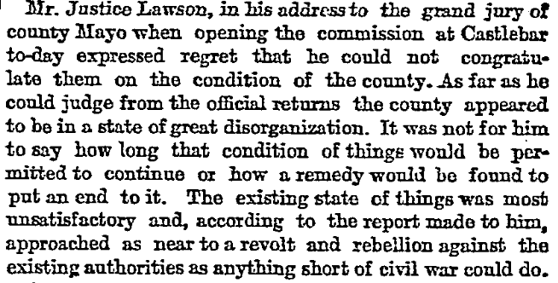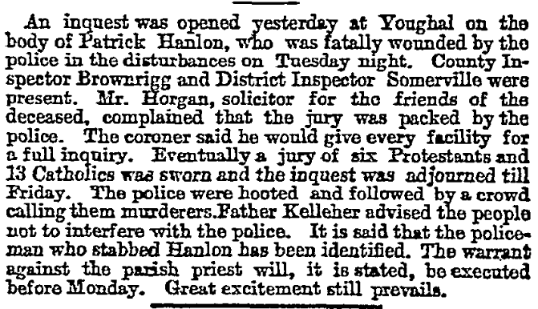
The Times Thu, 10 Mar 1887

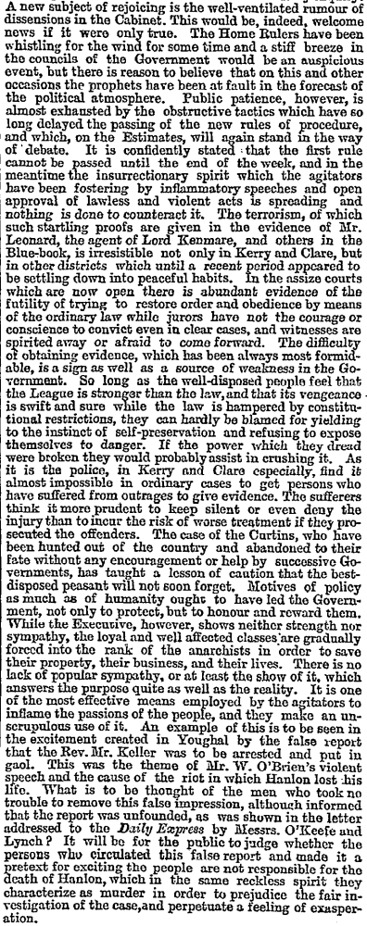
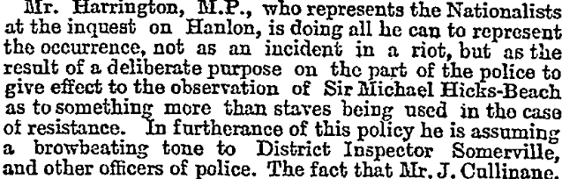
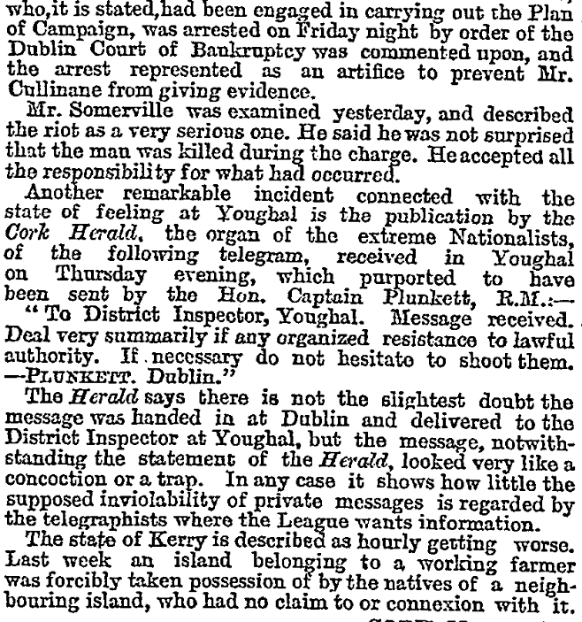
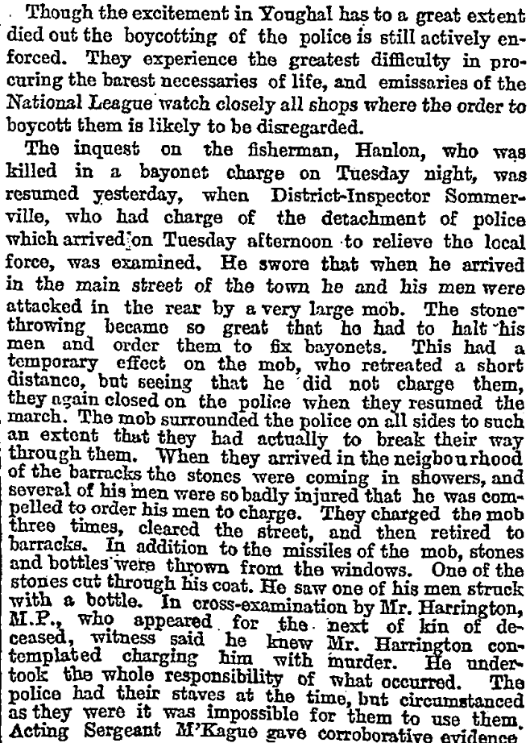
The Times Monday 14 Mar 1887
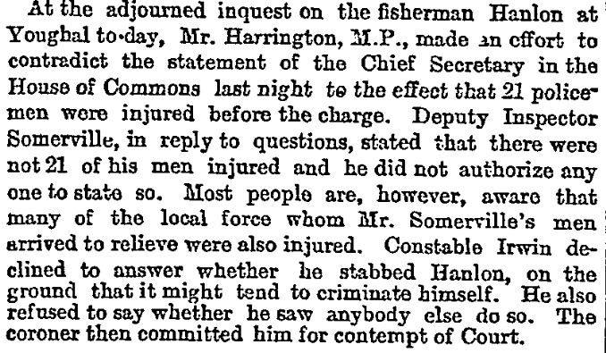
The Times Thursday 17 Mar 1887
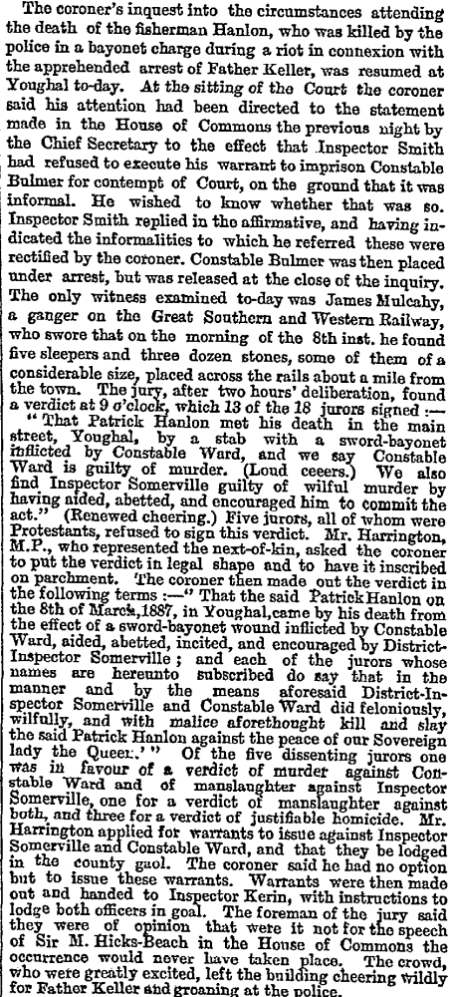

The Times 23 Mar 1887

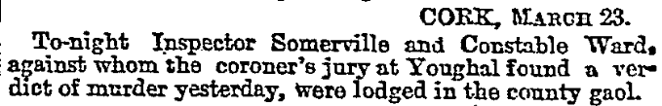
The Times 24 Mar 1887

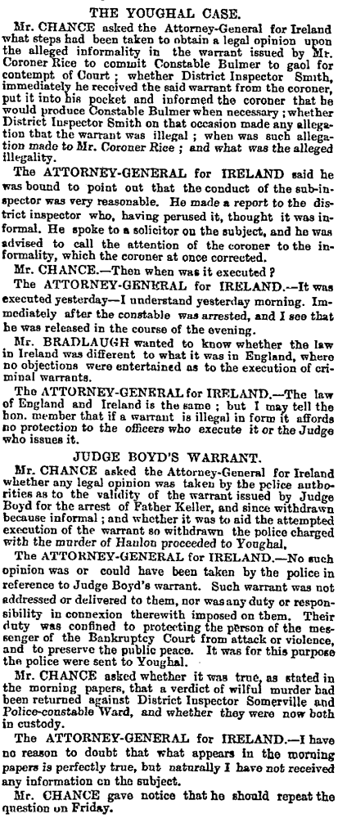
The Times Thurs 24 Mar 1887

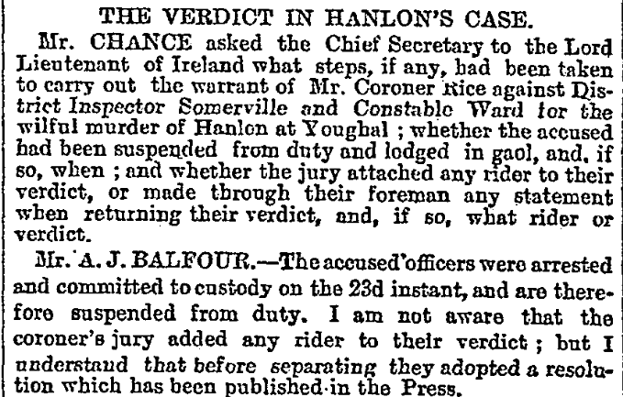
The Times Sat 26 Mar 1887

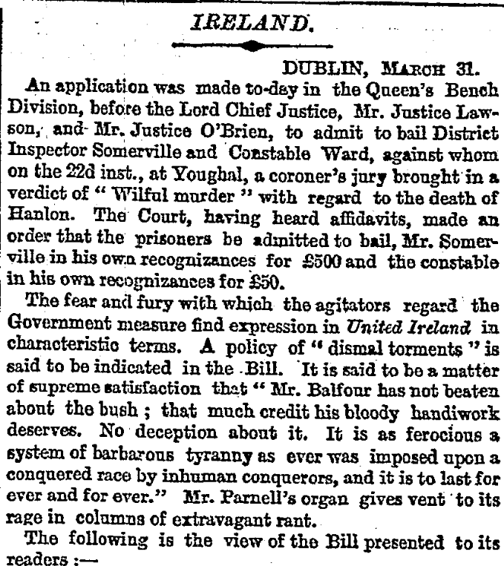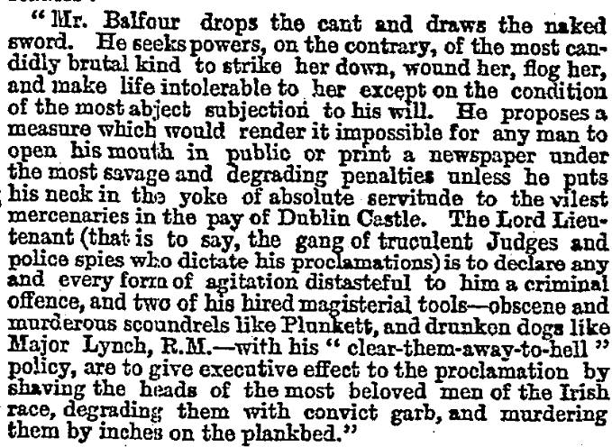

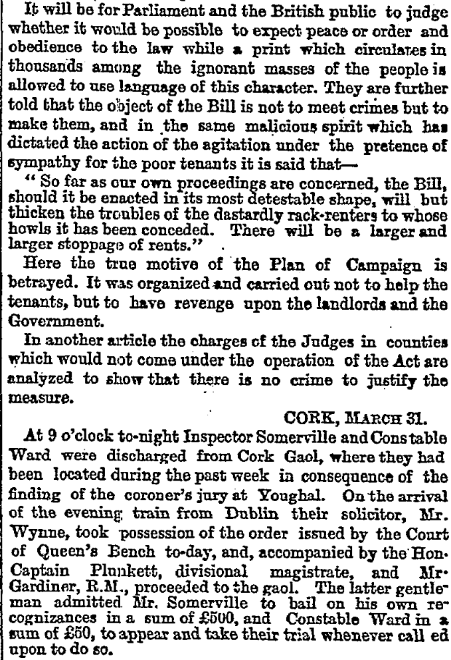

The Times 1 Apr 1887
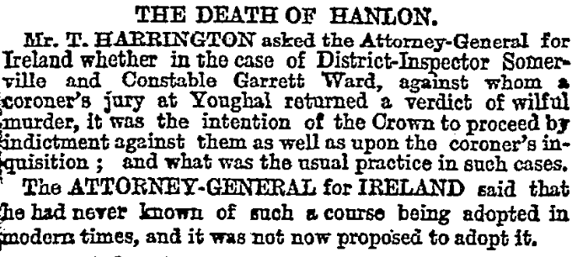 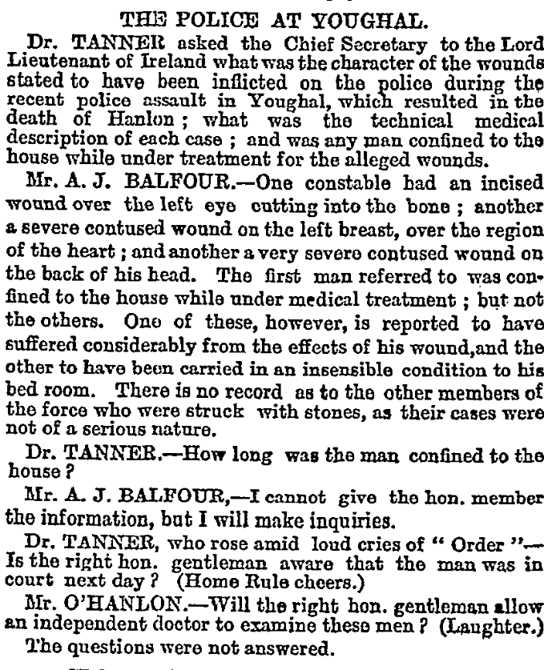The Times Tues 5 Apr 1887

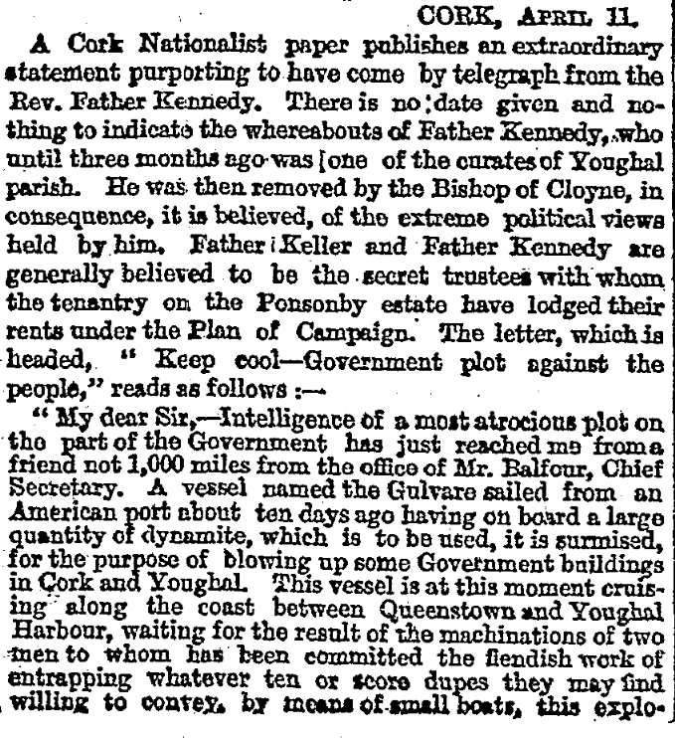
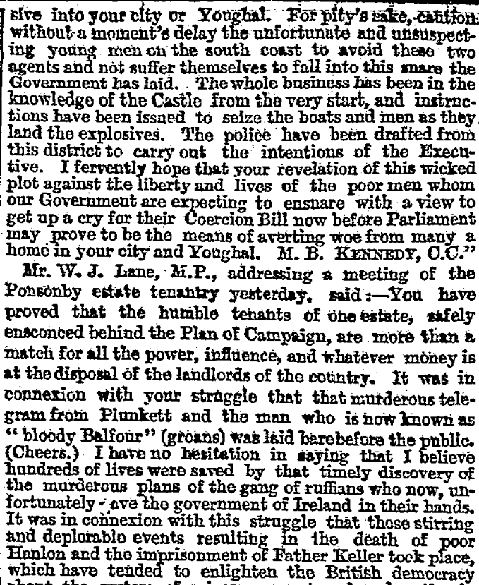
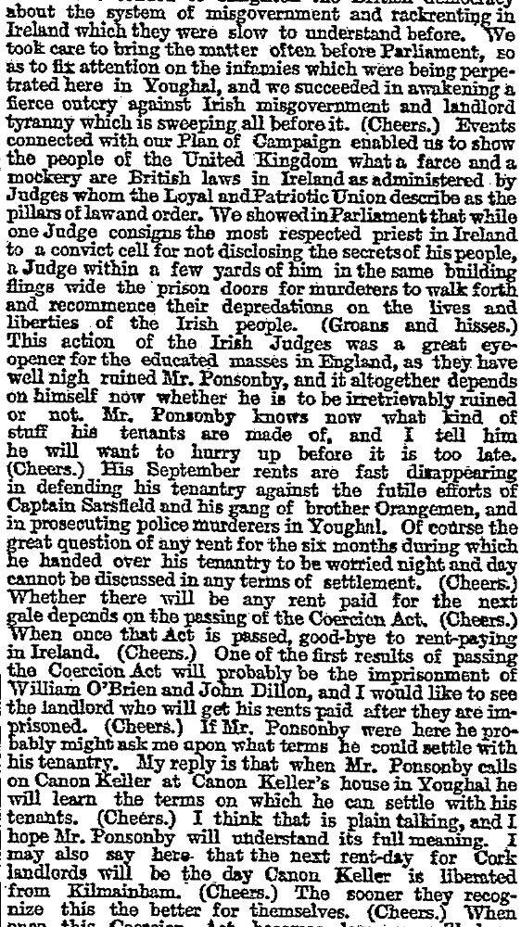
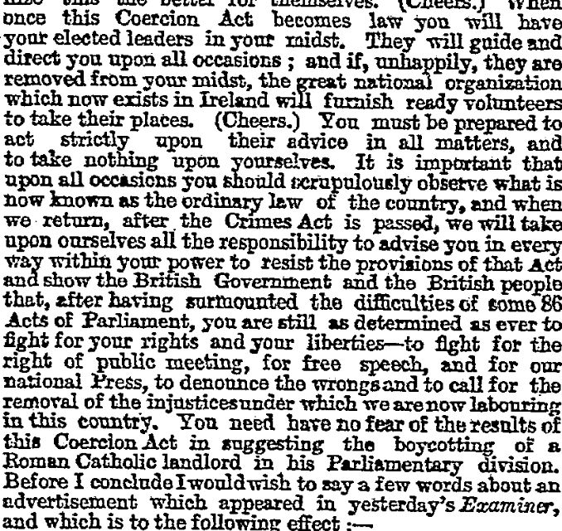

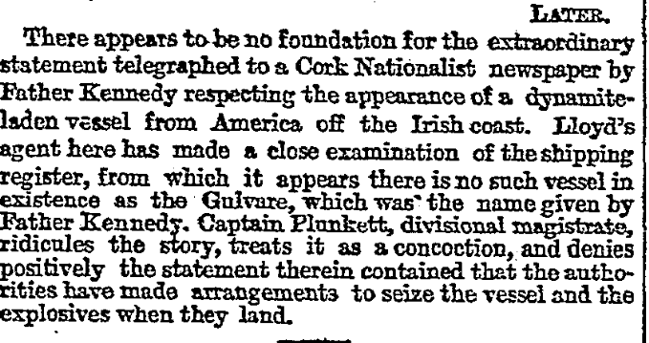
Tues 12 Apr 1887

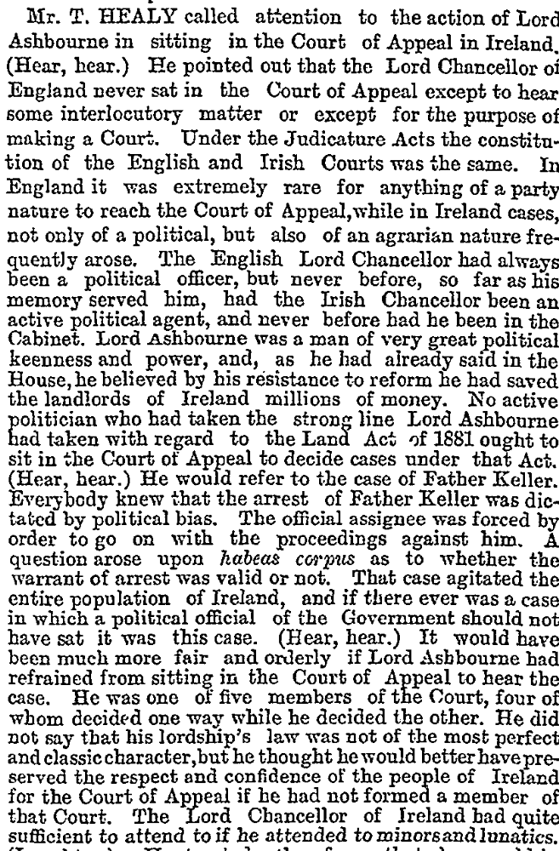
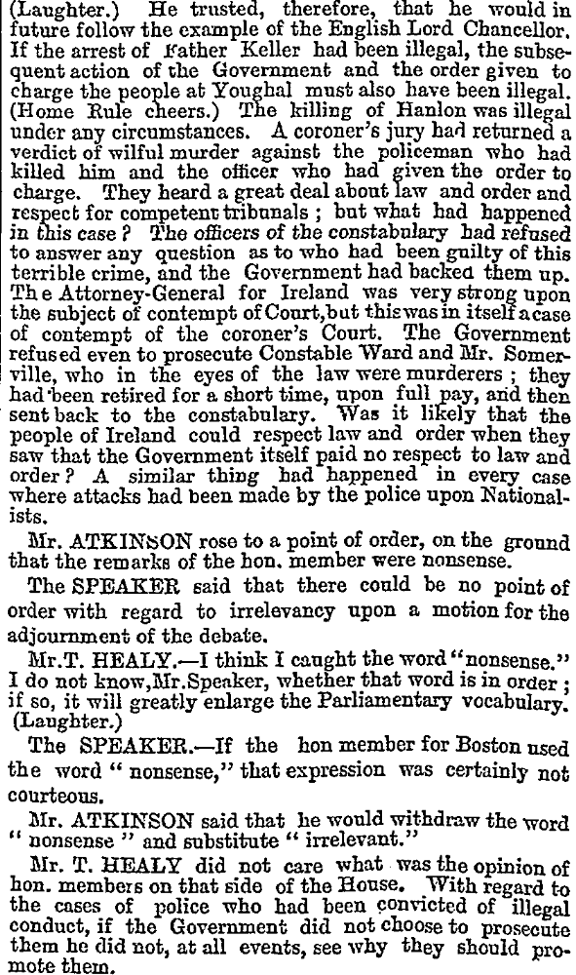
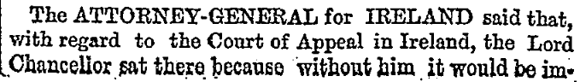
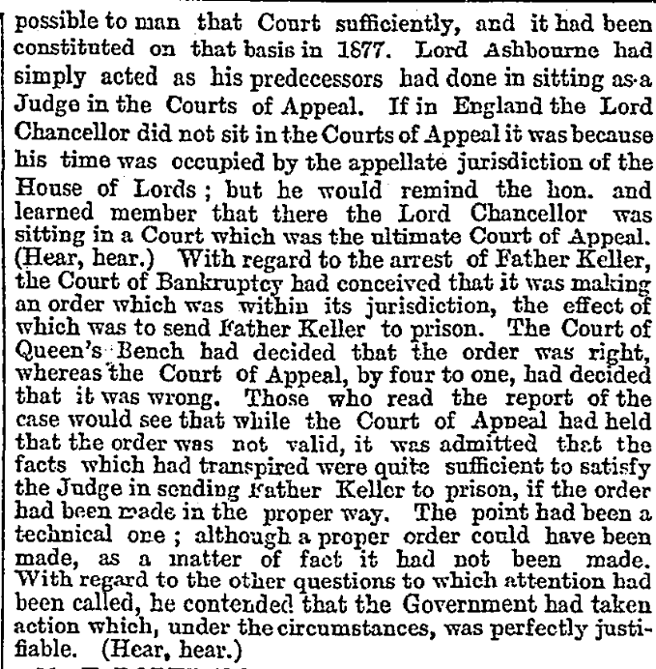
The Times 25 May 1887

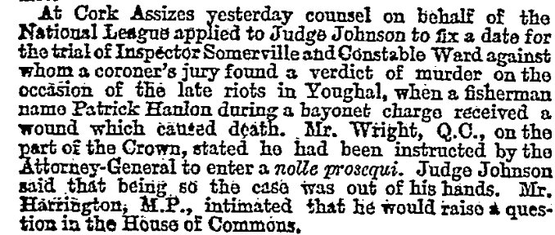
The Times Mon 25 Jul 1887

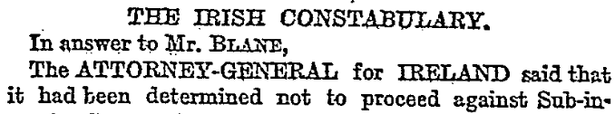
The Times Friday 9 Sept 1887

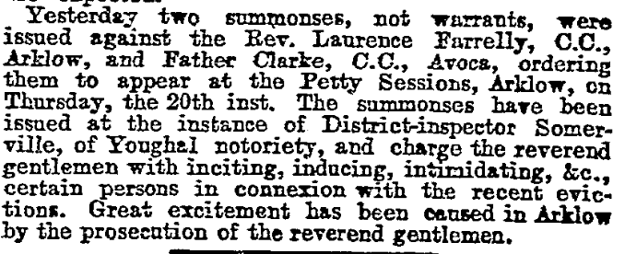Thurs 13 Sept 1887

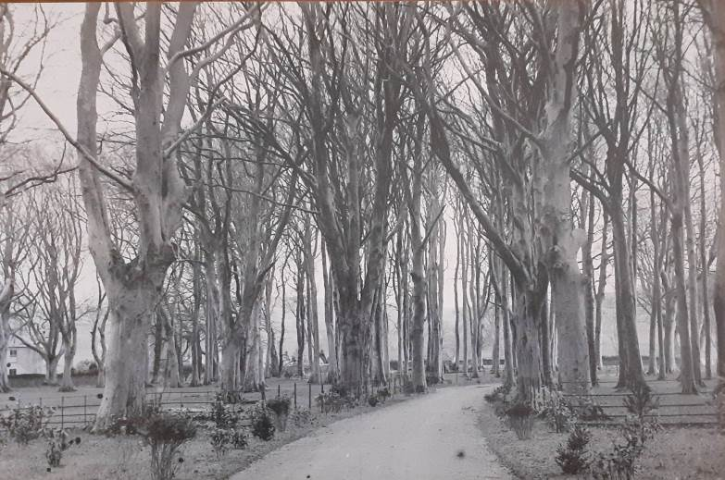

The main avenue looking down towards the Lodge and Newrath Road from the house about 1894/5

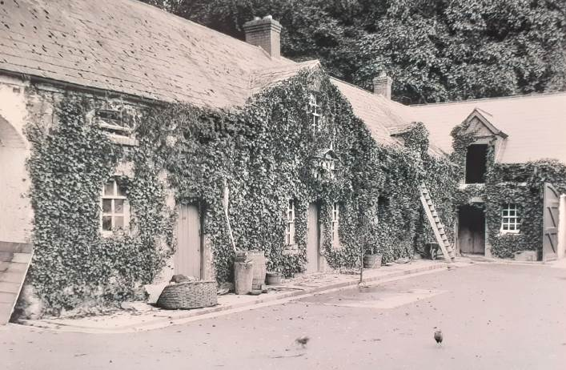

The yard, taken from the side entrance from the house, showing the entrance arch on the left, the storeroom and carpentry shop, Wilson’s kitchen, the stables and, on the extreme right, the garages.

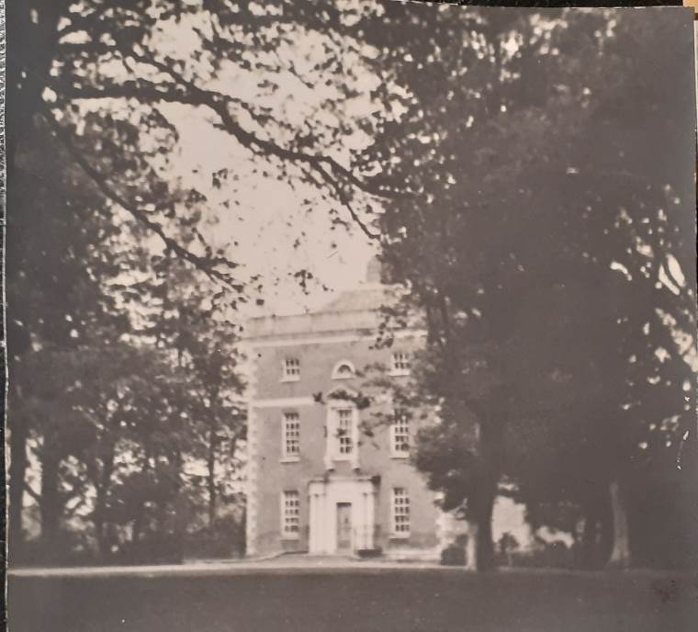

Clermont (originally called Newrath House) just before the family bought it in 1894

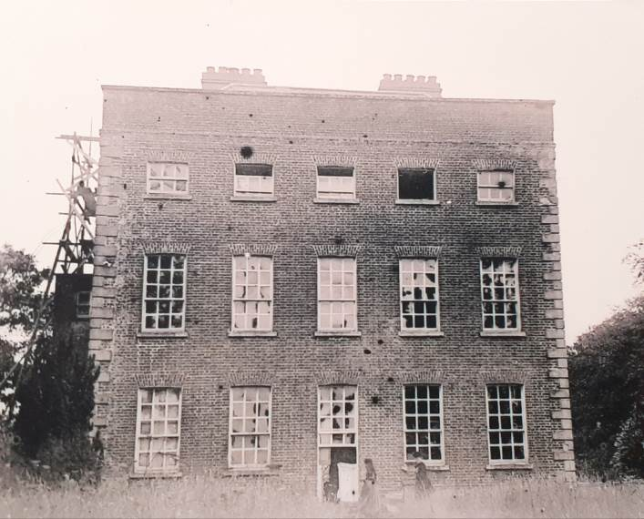

The back of the house as work on extensions and repair started 1894/5.

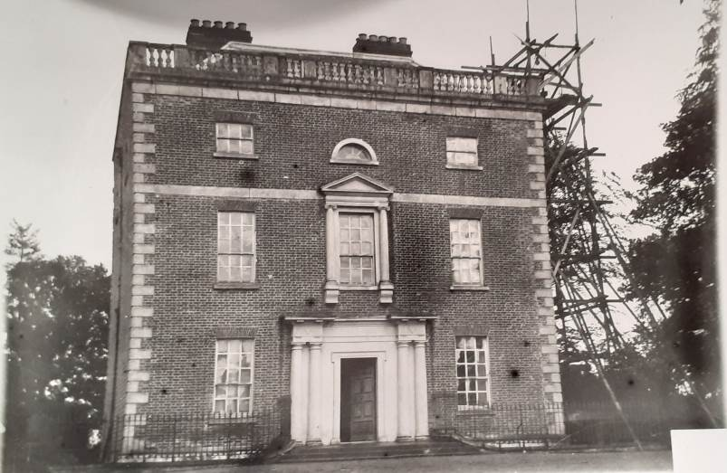
The front of the house during the repairs and extension 1894/5

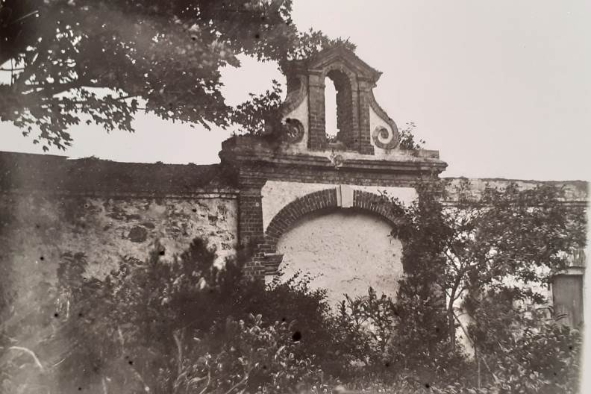
The Flemish Belfry on the south side of the yard looking from the house

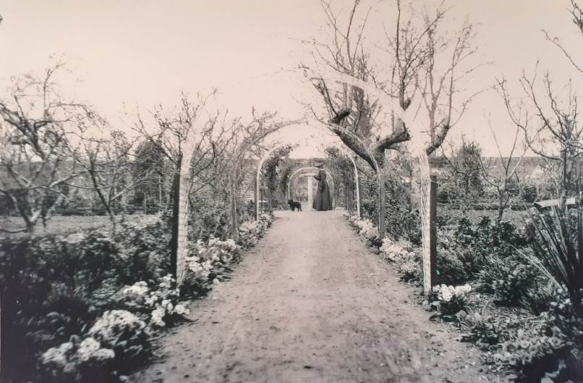
The first garden looking from the wooden gate

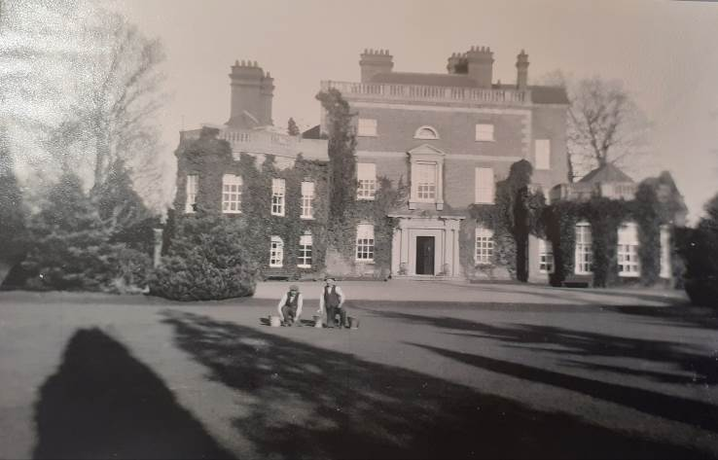
The house when the repairs and extension complete ,about 1908

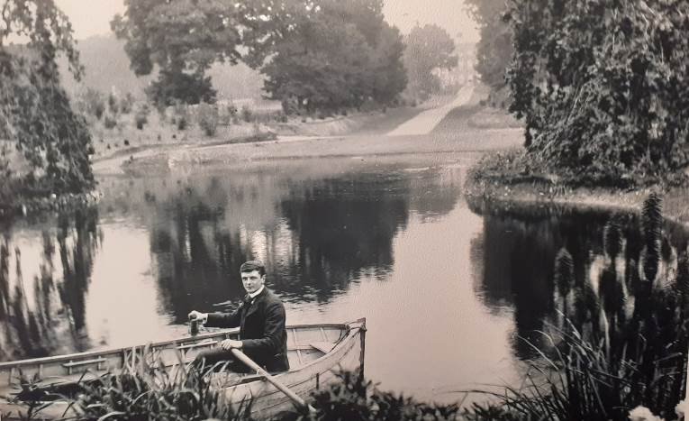
Jim on the pond about 1908/10 looking from outside the first garden across the pond up the garden path to the east side of the house

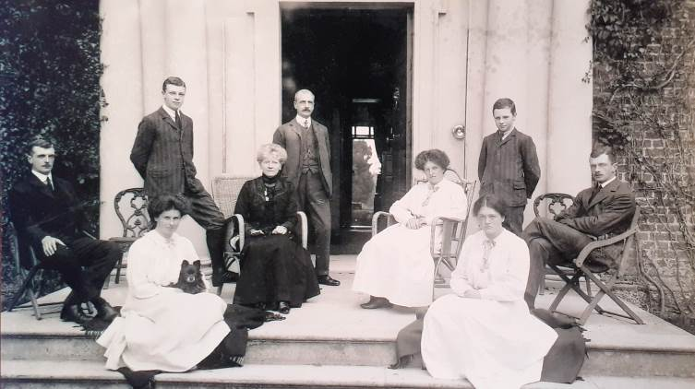

The family about 1908 0n the front steps.
Back row: Pat, BAS, Regi
Middle row: Jim, Dick, Vere, Bunt
Front row: Cecil,Ede

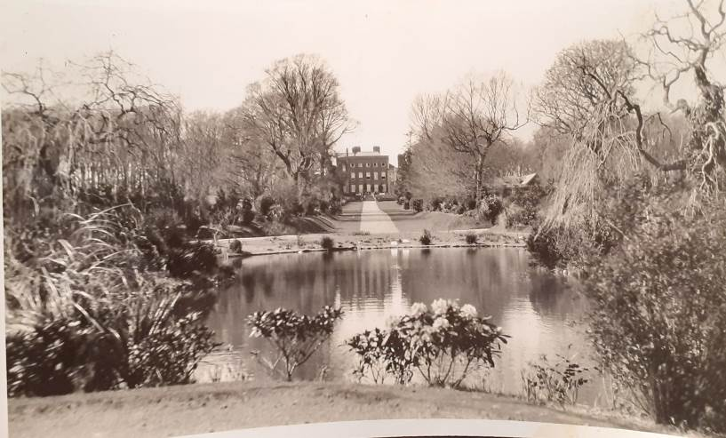
Looking across the pond from outside the first garden, up the garden path to the east side of the house

L

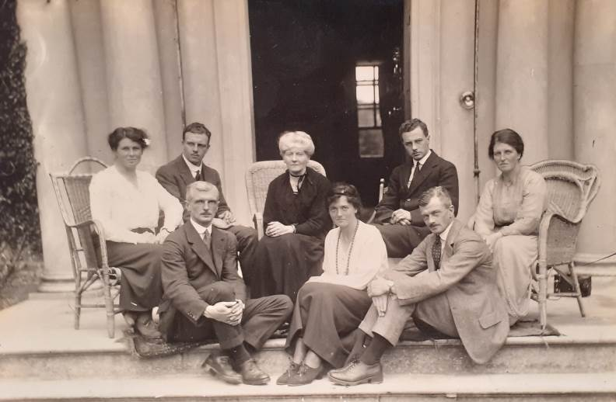
The family about 1924/5.
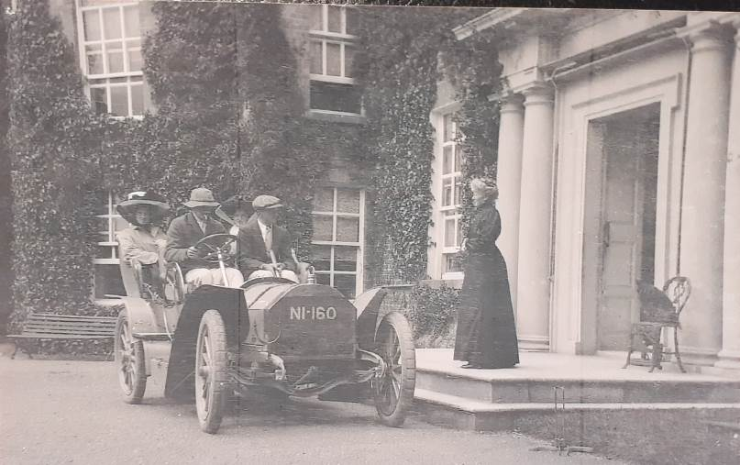

An early car, possibly belonging to Jim.

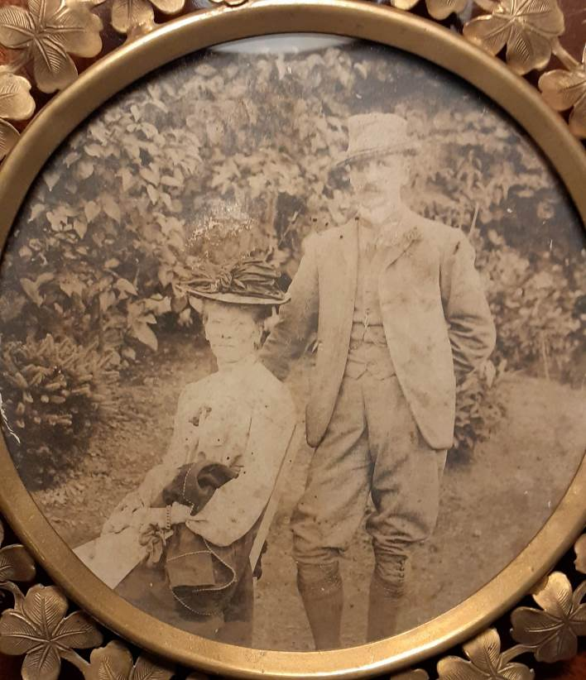
BAS and ‘Dick’

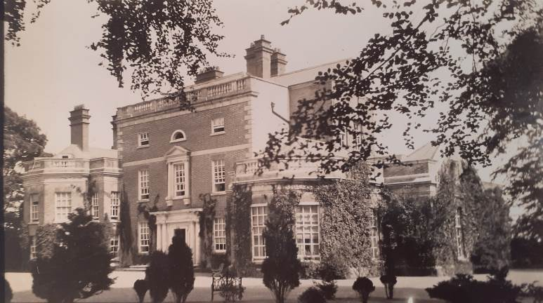
Clermont and the South Wing 1904
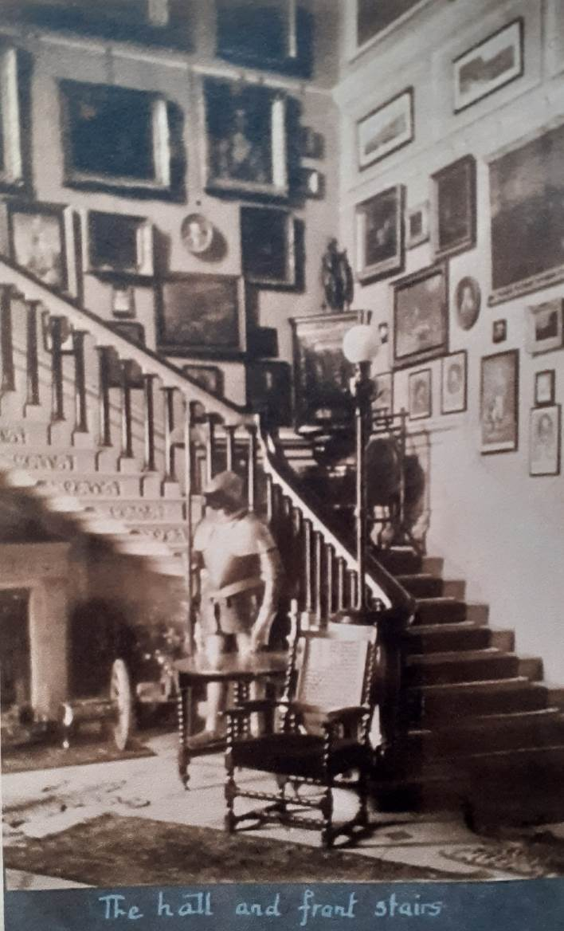
Clermont Hall and Stairs about 1936

